# Custom Update Centers for CloudBees Jenkins Operations Center

Goal

This lab will cover how to utilize Custom Update Centers in a CloudBees Jenkins Operations Center context with client masters.

Pre-steps

Log into CloudBees Jenkins Operations Center and ensure that you have a client master configured, as well as an available internet connection.

Step 1. Creating an update center

The first step is to create a Custom Update Center, which is a dashboard-level object. Click on the “New Item” link in the left-hand menu and selected the “Update center” object type. Name the update center “cjoc-updates” and click “Ok” to continue.

You will now be sent to the configuration page for this new update center. Leave the default configuration for the plugin versioning strategy and certification signature provider. You will then need to add an upstream source to provide the update center with content, so click on the “Add” button in the Content section and select the “CloudBees Jenkins Update Center” option for this lab. Leave the stream and Jenkins version with their default settings. For the purposes of this lab, don’t configure a maintenance task and just save this initial configuration.

Now that this update center exists, we will need to populate it with plugins. Since this update center is empty, click on the “Pull everything” link in the left-hand menu. 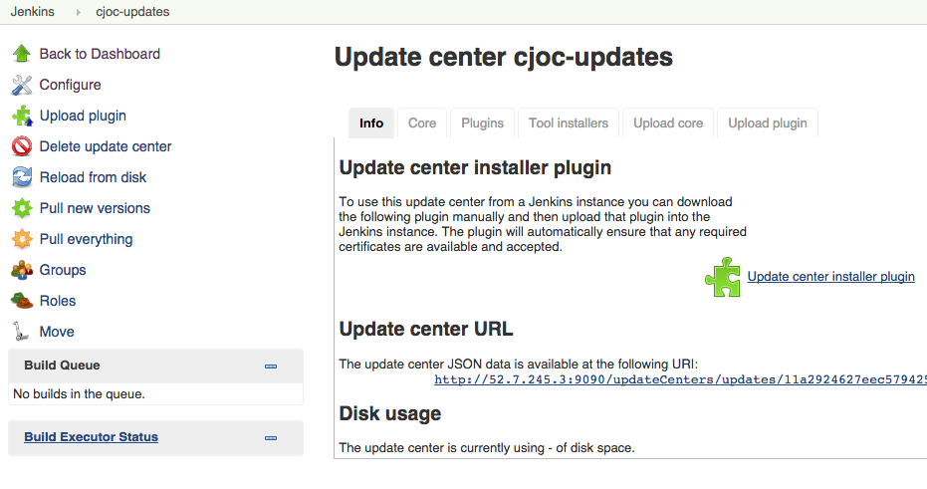

You will be asked to confirm the pull, so click “Yes”. CloudBees Jenkins Operations Center will then attempt to pull all plugins from the specified update center, in this case the CloudBees curated Enterprise update center.

Step 2. Connecting to client masters

While waiting for the plugin pull to finish, go back to the top-level page of CloudBees Jenkins Operations Center. Open up the configuration page for the client master by clicking on the black arrow to the right of the master’s name and selecting the “Configure” option:

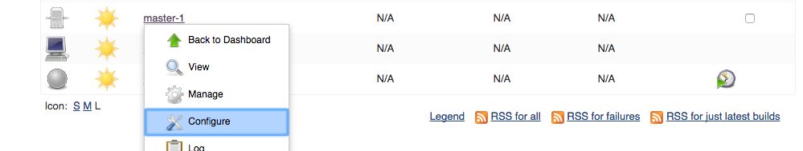

Now check the “Specify update center for Master” option on the client master configuration page, then select the “Update Center hosted on this Jenkins instance” radio option. Since this is our first and only custom update center, the “cjoc-updates” update center should be selected by default. Now save your configuration change and you will be re-directed to the client master’s top page.

Click on the “Manage Jenkins” link in the left-hand menu and select the “Manage Plugins” item in the main menu.

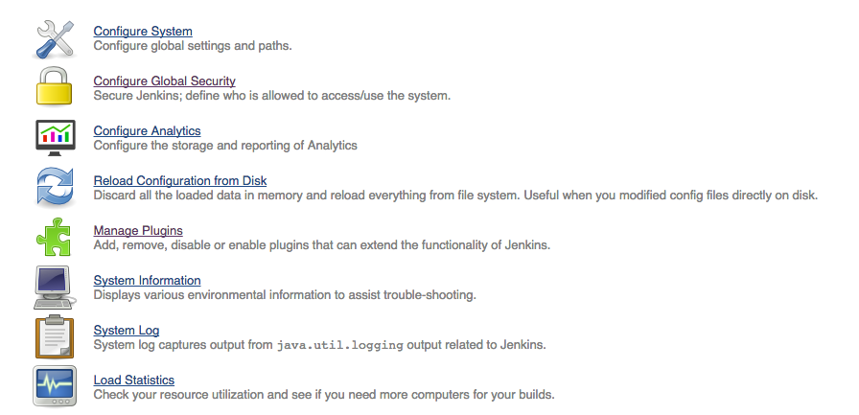

Click on the “Available” tab in the plugin manager, and observe how there are now no plugins listed. This is because the custom update center is managing this client master’s list of available plugins, and since no plugins have been promoted, none are listed.

Step 3. Promotion

Return to the CloudBees Jenkins Operations Center top page and, if the plugin pulls are still in the build queue, wait for the plugins to finish downloading.

Now click on “cjoc-updates” and click on the “Plugins” tab. Since the pull has completed, you will see a list of all plugins pulled from the CloudBees Jenkins Enterprise update center.

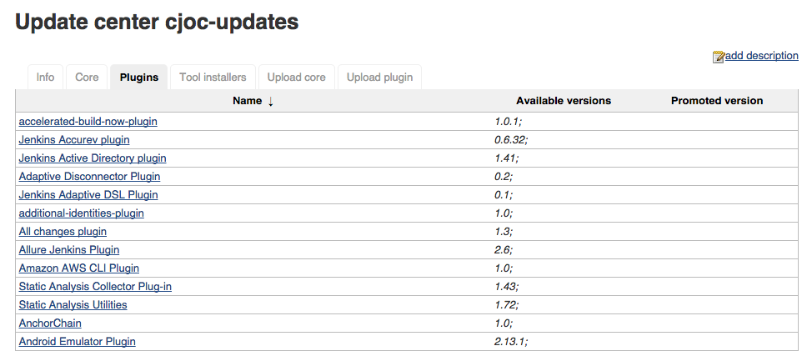

To enable the client master to download plugins from its update center, we need to promote plugins from the list of plugins in the update center.   
  
To do this, click on the name of any plugin and select either a specific version of the plugin to promote or the “latest” version. Many plugins are dependent on others, so if the plugin you have selected has a dependency you will see a warning about said dependency:

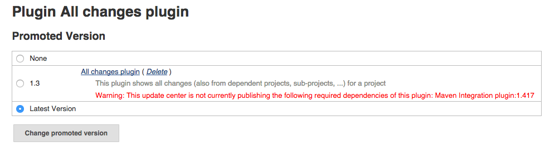

After selecting your desired version, click the “Change promoted version” button. This will promote the plugin to the downstream master’s update center and allow the master to download that plugin.

Repeat this process as desired for other plugins, then navigate to the client master and open its Plugin Manager as before. However, click on the “Advanced” tab instead of the “Available” and scroll to the bottom of the page. In the bottom right-hand corner is a “Check Now” button. Click on this button to force this Jenkins master to pull the latest plugin metadata from the upstream update center, in this case our “cjoc-updates” update center.

Now click on the “Available” tab, and you should see a list with only the plugins and versions you promoted earlier.

